EMG Based Lateral and Palmar Hand Movements Classification System Using Naive Bayes Classifier
Implemented Using Python

Abdel Rahman Alaa Eldin Mahmoud
Systems & Biomedical Engineering. Faculty of Engineering
Cairo University
Giza, Egypt
Mohsen Ahmed Elmansy
Systems & Biomedical Engineering. Faculty of Engineering
Cairo University
Giza, Egypt

Muhammad Moustafa Kamal
Systems & Biomedical Engineering. Faculty of Engineering
Cairo University
Giza, Egypt
muhammad.moustafa95@eng-st.cu.edu.eg

Abstract—This paper describes the process of implementing a Naive Bayes Classifier to differentiate between two types of hand movements -palmar and lateral- using two files contain the different readings for both movements
Keywords— Naive Bayes Classiffier , Machine Learning , Statistics , Python

Introduction
Electromyography (EMG) is electro diagnostic medicine technique for evaluating and recording the electrical activity produced by skeletal muscle. EMG is performed using an instrument called an electromyograph to produce a record called an electromyogram. The signals can be analyzed to detect medical abnormalities, activation level, or recruitment order, or to analyze the biomechanics of human or animal movement. Researchers have tried since the inception of computers to develop techniques and algorithms for automated processing of EMG signals for various medical applications, whether as standalone applications or as a decision aid to physicians. However, patterns of an EMG signal are difficult to discern due to the multitude of characteristics that are embedded in the signal. As a result, researchers have focused on developing specific techniques to extract information from EMG’s for specific applications. This paper describes a Naive Bayes Classifier to differentiate between palmar and lateral hand movements.

Theoretical Background
A naive Bayes classifier is a simple probabilistic classifier based on applying Bayes' theorem with strong (naive) independence assumptions.
In machine learning, naive Bayes classifiers are a family of simple probabilistic classifiers based on applying Bayes' theorem between the features.
Naive Bayes is a simple technique for constructing classifiers: models that assign class labels to problem instances, represented as vectors of feature values, where the class labels are drawn from some finite set. There is not a single algorithm for training such classifiers, but a family of algorithms based on a common principle.
When dealing with continuous data, a typical assumption is that the continuous values associated with each class are distributed according to a Gaussian distribution. For example, suppose the training data contains a continuous attribute x. We first segment the data by the class, and then compute the mean and variance of x in each class. Let µ be the mean of the values in x associated with class c and let d_{c}² be the variance of the values in x associated with class c. Suppose we have collected some observation value v Then, the probability distribution of v given a class p(x = v|c) can be computed by plugging v into the equation for a Normal distribution parameterized by u and variance that is,.^{[2]}
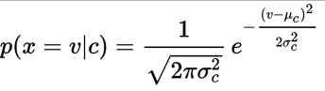 (1)

Proposed System

Dataset Formulation
The EMG records are in the form of two 2D array(150*3000) matlab files.

Reading Data
Using scipy.io.loadmat to read the matlab files.^{[3]}
The data is divided into100 to train and 50 to test.
We used the numpy.random.shuffle() function to shuffle the data and obtain more accurate results but all the results we mentioned here are obtained by performing the process on the original data.

Preprocessing
It's the process of cleaning the signal from irrelevant noise.
We used the iirfilter and lfilter^{[4]} with order 3 and sampling frequency = 1000Hz for both files to remove power line frequency noise (50Hz).
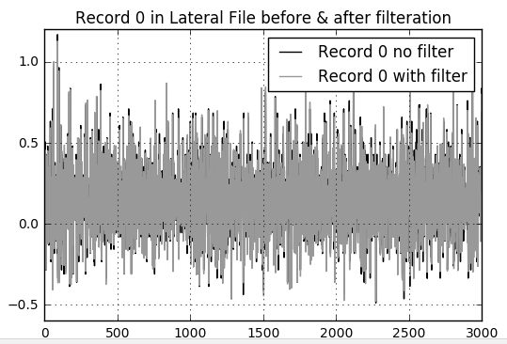
Figure 1

Feature Extraction and Feature Selection
As proposed by the teaching assistant to skip the feature extraction step and select the 4 following features.
Energy = SX_{i}² (2)
4th power = SX_{i}⁴ (3)
Nonlinear Energy = S-X_{i}*X_{i-2} + X_{i-1}² (4)
Curve Length = SX_{i}-X_{i-1} (5)

Building Classifier Model
EMG signal classification is the final step. There are several methods to classify EMG, the paper discusses one method of supervised learning: Naïve Bayes Decision Theory.

Naïve Bayes Decision Theorem
We assume that all the used features in Naive Bayes model have Gaussian distribution and independent, so we can use probability density function (pdf) value as an estimate for the conditional probability
As applied in a medical context, a conditional probability is the likelihood of some class/conclusion, C, given some evidence/observation, E, where a dependence relationship exists between C and E. This probability is denoted as
P (C| E) where

P(C|E) =P(E|C) ·P(C)/P(E) (6)

From the statistical analysis, the probability of the class is constant and as the same the evidence.
To determine the many probabilities. In order to reduce the number of required data samples, an assumption of independence can be made for the components of E, letting the joint probability take the form of
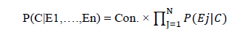 (7)
To test signals to be palmar or lateral, we wish to determine which posterior is greater, palmar or lateral. For the classification as lateral the posterior is given by
Posterior(lateral)=P(lateral)p(Energy|lateral)p(4thPower| lateral)p(Nonlin.Energy|lateral)p(CurveLength|lateral)/ evidence (8)

Posterior(palmar)=P(palmar)p(Energy|palmar)p(4thePower|palmar)p(Nonlin.Energy| palmar) p(Curve Length| palmar) / evidence. (9)
P(lateral) and P(palmar) depends on the number of each class of them selected to training process.
The evidence may be calculated:
evidence = P(lateral)p(Energy|lateral)p(4thPower| lateral) p(Nonlin.Energy|lateral)p(CurveLength|lateral)+P(palmar) p(Energy|palmar)p(4thPower|palmar)p(Nonlin.Energy|palmar) p(CurveLength| palmar) (10)
Then the classification ends with calculating the probabilities of the two classes lateral and palmar, the record with the correct higher probability passes the test.
Here we can see the Energy feature for the two files as an example.
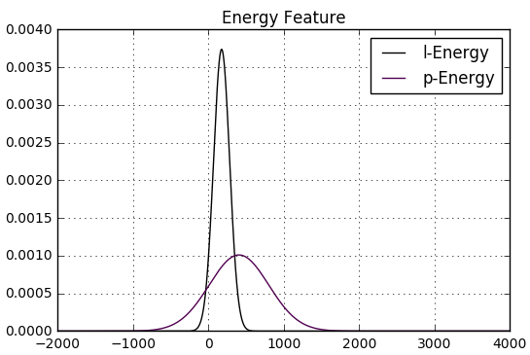
Figure 2
Note: The figure is plotted using the first 100 record in each file.

Assess The Performance of The Classifier
Here we used the Hold-out Method, We divided the data into two sets : training set -100 records from each file- and testing set -50 records from each file-.
This is the confusion matrix obtained from the project.
Confusion Matrix | Predicted Class
True Class | Lateral | Palmar
Positive | 49 | 30
Negative | 1 | 20

References

- http://stats.stackexchange.com/questions/18212/origin-of-the-na%C3%AFve-bayes-classifierJ.
- https://en.wikipedia.org/wiki/Naive_Bayes_classifier#Gaussian_naive_Bayes
- https://docs.scipy.org/doc/scipy/reference/generated/scipy.io.loadmat.html.
- https://docs.scipy.org/doc/scipy-0.14.0/reference/generated/scipy.signal.iirfilter.html.

We used the accuracy as the metric function for the classifier.

Accuracy = (True palmar + True lateral) / Total (11)

and as we can see The obtained accuracy is 79% "without shuffling".

